Exercise 1 – Create and Read a File
Workflow
create_file
↓
read_file
Task 1: Create file
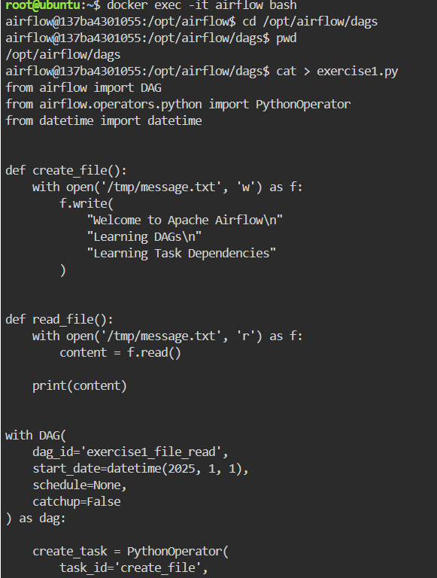

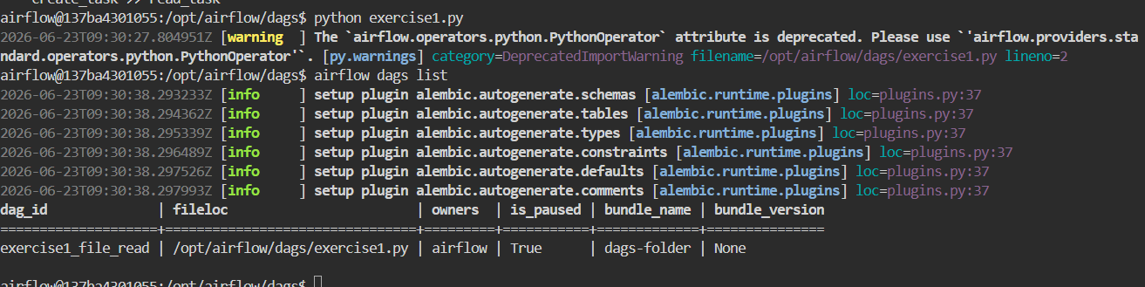
Python code:
from airflow import DAG
from airflow.operators.python import PythonOperator
from datetime import datetime

def create_file():
with open('/tmp/message.txt', 'w') as f:
f.write(
"Welcome to Apache Airflow\n"
"Learning DAGs\n"
"Learning Task Dependencies"
)

def read_file():
with open('/tmp/message.txt', 'r') as f:
content = f.read()

print(content)
with DAG(
dag_id='exercise1_file_read',
start_date=datetime(2025, 1, 1),
schedule=None,
catchup=False
) as dag:
create_task = PythonOperator(
task_id='create_file',
python_callable=create_file
)
read_task = PythonOperator(
task_id='read_file',
python_callable=read_file
)
create_task >> read_task

Task 2
Read the file and print its contents in task logs.
